**Difference between Full Virtualization and Paravirtualization**

1. **Full Virtualization:**
   1. Full Virtualization was introduced by IBM in the year 1966.
   2. It is the first software solution for server virtualization and uses binary translation and direct approach techniques.
   3. In full virtualization, guest OS is completely isolated by the virtual machine from the virtualization layer and hardware.
   4. Microsoft and Parallels systems are examples of full virtualization. 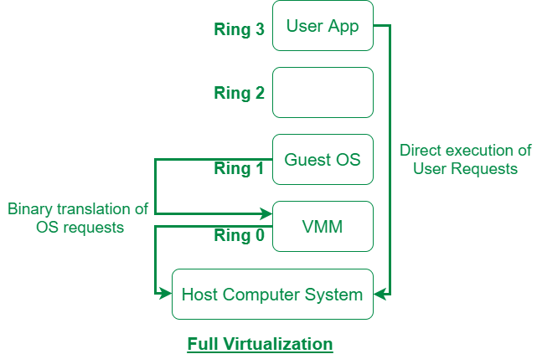
2. **Paravirtualization:**
   1. Paravirtualization is the category of CPU virtualization which uses hypercalls for operations to handle instructions at compile time.
   2. In paravirtualization, guest OS is not completely isolated but it is partially isolated by the virtual machine from the virtualization layer and hardware.
   3. VMware and Xen are some examples of paravirtualization. 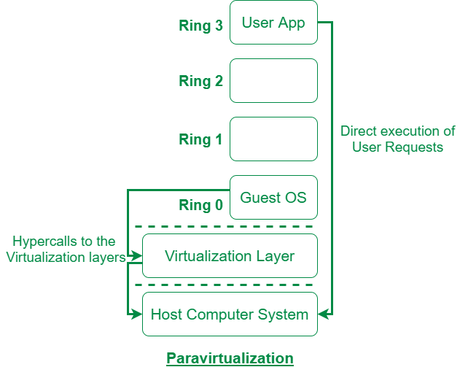

The difference between Full Virtualization and Paravirtualization are as follows:

| **S.No.** | **Full Virtualization** | **Paravirtualization** |
| --- | --- | --- |
| 1. | In Full virtualization, virtual machines permit the execution of the instructions with the running of unmodified OS in an entirely isolated way. | In paravirtualization, a virtual machine does not implement full isolation of OS but rather provides a different API which is utilized when OS is subjected to alteration. |
| 2. | Full Virtualization is less secure. | While the Paravirtualization is more secure than the Full Virtualization. |
| 3. | Full Virtualization uses binary translation and a direct approach as a technique for operations. | While Paravirtualization uses hypercalls at compile time for operations. |
| 4. | Full Virtualization is slow than paravirtualization in operation. | Paravirtualization is faster in operation as compared to full virtualization. |
| 5. | Full Virtualization is more portable and compatible. | Paravirtualization is less portable and compatible. |
| 6. | Examples of full virtualization are Microsoft and Parallels systems. | Examples of paravirtualization are Microsoft Hyper-V, Citrix Xen, etc. |
| 7. | It supports all guest operating systems without modification. | The guest operating system has to be modified and only a few operating systems support it. |
| 8. | The guest operating system will issue hardware calls. | Using the drivers, the guest operating system will directly communicate with the hypervisor. |
| 9. | It is less streamlined compared to para-virtualization. | It is more streamlined. |
| 10. | It provides the best isolation. | It provides less isolation compared to full virtualization. |